Chapter 3 Solutions:

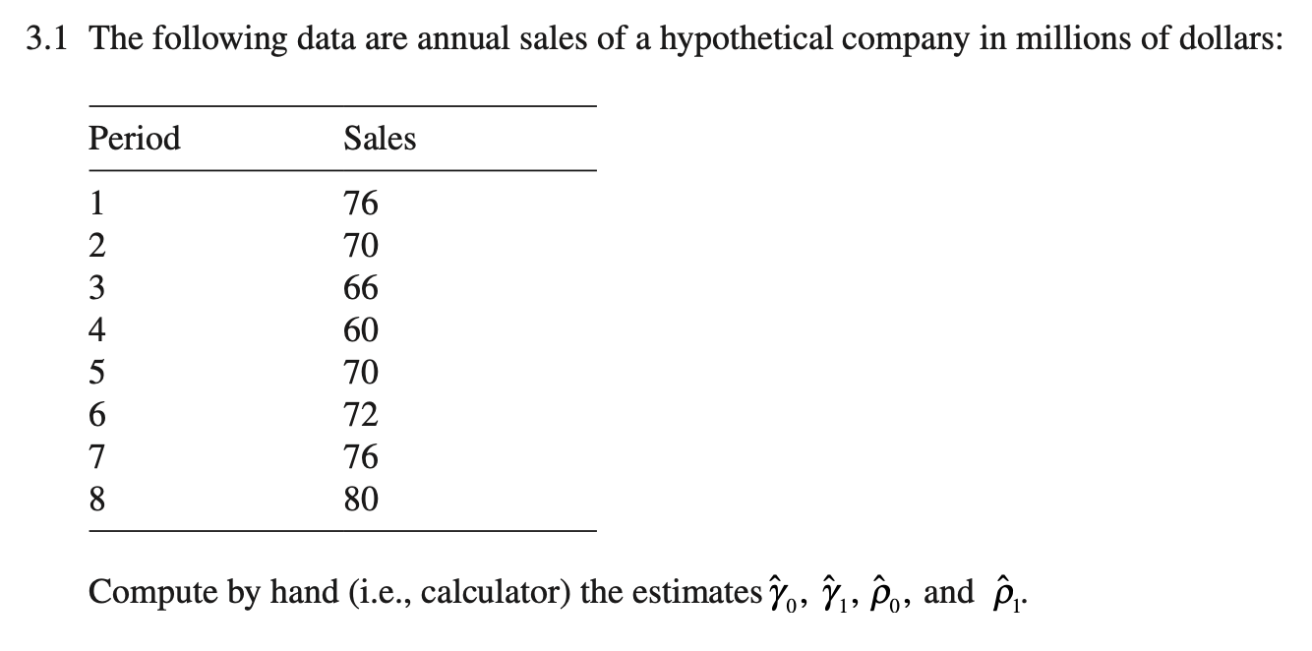

4. 1. C. 2. A. 3. D. 4. B.

|  |  |
| --- | --- |
|  |  |
|  |  |
|  |  |
|  |  |
|  |  |

5.1.B. 2. D. 3. C 4. A

|  |  |
| --- | --- |
|  |  |
|  |  |
|  |  |
|  |  |
|  |  |

9.

$x_{i}-\overline{x}$ will be positive when X is greater than xbar and negative when x is less than xbar.

will be positive when y is greater than xbar and negative when y is less than ybar.

Will be positive when X is greater than xbar and y is greater than ybar(the upper right hand quadrant of a scatterplot)

Will be positive when X is less than xbar and y is less than ybar(the lower left hand quadrant of a scatterplot)

Will be negative when X is less than xbar and y is greater than ybar(the upper left hand quadrant of a scatterplot)

${(x}_{i}-\overline{x}){(y}_{i}-\overline{y})$ Will be positive when X is greater than xbar and y is less than ybar(the lower right hand quadrant of a scatterplot)

Note that in plots like 3.3(d) points are distributed in all four quandrants relatively equally. This mean that there will be about the same number of positive and negative cross products (with similar magnitudes). For this reason the expression $\sum_{i=1}^{n}{{(x}_{i}-\overline{x}){(y}_{i}-\overline{y})}$ will be the sum of positive and negative cross-products of similar magnitude which means that the sum will be about zero.

Since $r_{XY}=\frac{\sum_{i=1}^{n}{{(x}_{i}-\overline{x}){(y}_{i}-\overline{y})}}{σ_{x}σ_{Y}}$, $r_{XY}$ will be approximately zero.

10.

$x_{i}-\overline{x}$ will be positive when X is greater than xbar and negative when x is less than xbar.

$y_{i}-\overline{y}$ will be positive when y is greater than xbar and negative when y is less than ybar.

Will be positive when X is greater than xbar and y is greater than ybar(the upper right hand quadrant of a scatterplot)

Will be positive when X is less than xbar and y is less than ybar(the lower left hand quadrant of a scatterplot)

Will be negative when X is less than xbar and y is greater than ybar(the upper left hand quadrant of a scatterplot)

${(x}_{i}-\overline{x}){(y}_{i}-\overline{y})$ Will be positive when X is greater than xbar and y is less than ybar(the lower right hand quadrant of a scatterplot)

The data in Fig 3.3 (f) are approximately equally distributed in lower left and upper right quadrants (positive cross-products) as they are in the upper left and lower right quadrants (negative cross-products). For this reason, summing the cross products will lead to a near zero sum and thus $r_{XY}$ will be approximately zero.

Since $r_{XY}=\frac{\sum_{i=1}^{n}{{(x}_{i}-\overline{x}){(y}_{i}-\overline{y})}}{σ_{x}σ_{Y}}$, $r_{XY}$ will be approximately zero.